Voltaire

[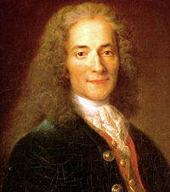](http://en.wikipedia.org/wiki/Image:Voltaire.jpg)